**Experiment No. - 1.1**

**Student Name: Deepak Saini UID: 20BCS4066**

**Branch: 20BCC1 Section/Group: A**

**Semester:**  **5th Date of Performance: 11/08/2022**

**Subject Name: ADVANCED PROGRAMMING LAB**

**Subject Code: 20CSP-334**

1. **Aim/Overview of the practical:**

To write a program in C++ the Kth  largest or Kth smallest element in an array using template and C++ STL.

1. **Task to be done:**

To write a program in C++ the Kth  largest or Kth smallest element in an array using template and C++ STL.

1. **Steps for practical**:
2. Include the header files.
3. Take the size of an array, array elements, and k.
4. Sort the array using STL sort.
5. Output the Kth largest/smallest element.

**4 . Code:**

1. **Kth Largest element :**

#include<bits/stdc++.h>

using namespace std;

int main()

{

int n;

cout<<"Enter the size of array: ";

cin>>n;

int arr[n];

cout<<"Enter array elements: ";

for(int i=0; i<n; i++)

{

cin>>arr[i];

}

int k;

cout<<"Enter the Kth largest element to output: ";

cin>>k;

sort(arr,arr + n);

cout<<"The Kth largest element of the array is: "<<arr[n-k]<<endl;

}

1. **Kth smallest element :**

#include<bits/stdc++.h>

using namespace std;

int main()

{

int n;

cout<<"Enter the size of array: ";

cin>>n;

int arr[n];

cout<<"Enter array elements: ";

for(int i=0; i<n; i++)

{

cin>>arr[i];

}

int k;

cout<<"Enter the Kth smallest element to output: ";

cin>>k;

sort(arr,arr + n);

cout<<"The Kth smallest element of the array is: "<<arr[k-1]<<endl;

}

**5.** **Output:**

a) 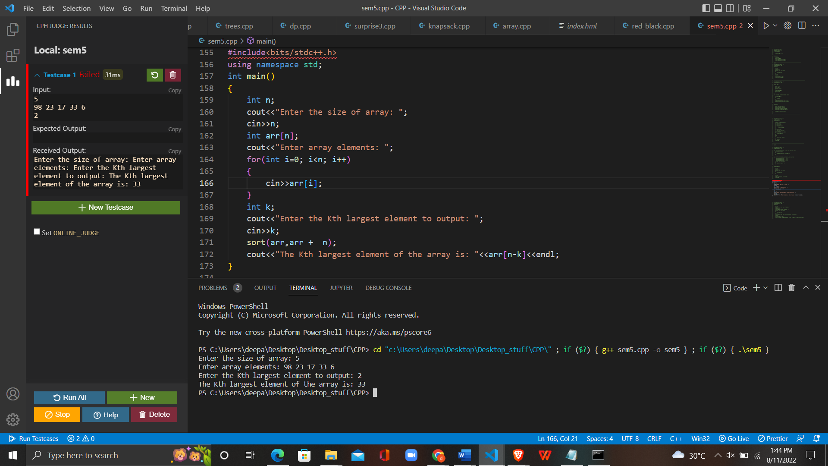

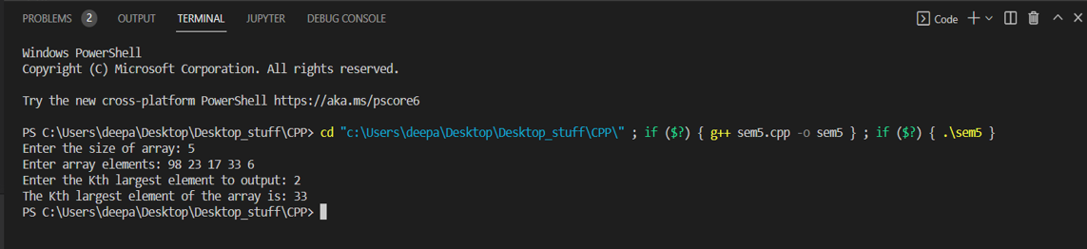

b)

